Answer 7
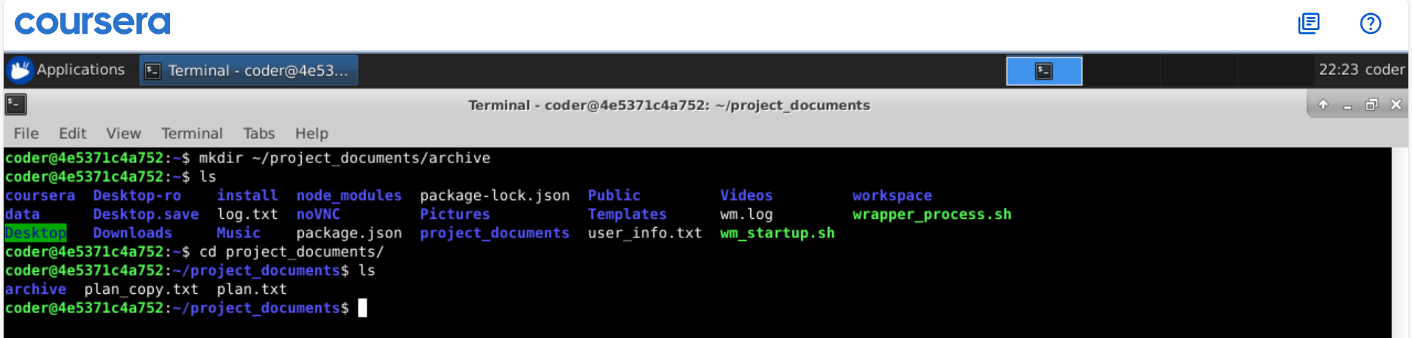
Explanation: Again using mkdir command we can create a directory and by providing the patch it can go as desired. Also, by using -p option we can create parent and subdirectories in 1 line.

